**TESPA CONSULTING SERVICES**

**STRUCTURED ROADMAP FOR GMS:**

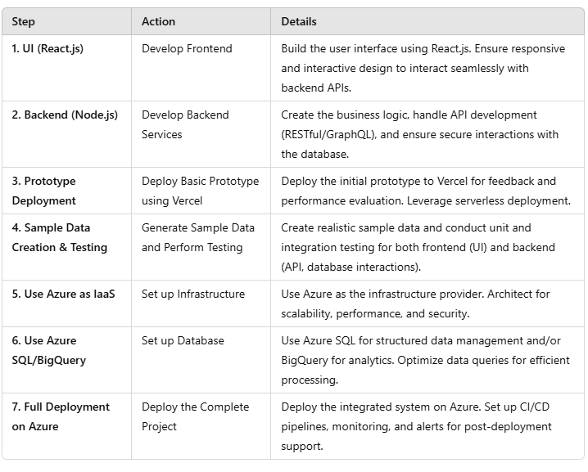 **TIMELINE:**

**1**. **UI (React.js)(1 week)**

* **Start with Frontend Development:** React.js is a good choice for building the user interface. You can focus on designing the layout, components, and ensuring responsive behavior for a smooth user experience.
* **Consider the interaction with Backend:** Ensure the frontend is designed to easily interact with the backend services (APIs) that will handle the data management.

### 2. ****Backend (Node.js)(3 weeks)****

* **Backend Development:** This is the correct next step after building the frontend. Node.js will handle the business logic, process requests, and interact with the database (Azure SQL/BigQuery).
* **Ensure API Development:** Develop RESTful APIs or GraphQL to interface with the frontend and handle data interactions securely.

### ****Basic Prototype Deployment Using Vercel (Serverless) (1 week)****

* **Prototype Deployment:** Deploying the prototype on Vercel will allow you to quickly test and iterate. It’s a good practice to deploy early for feedback and performance evaluation.
* **Serverless Model:** Vercel’s serverless architecture can be useful for scaling but ensure that any backend services are appropriately configured to support the deployment.

### 4. ****Creating Sample Data and Testing (1 week)****

* **Data Generation:** Creating sample data is an essential step for testing your software's functionality. Make sure your sample data mirrors real-world usage scenarios.
* **Unit and Integration Testing:** Along with sample data, ensure testing is comprehensive. Validate both frontend (UI) and backend (API, database interaction) functionalities.

### 5. ****Using Azure as IaaS (Infrastructure as a Service)(2 weeks)****

* **Hosting & Infrastructure:** Azure is a great choice for hosting the app’s backend services, database, and other resources. Ensure the infrastructure is well-architected for scalability, security, and performance.
* **Server-less Options in Azure:** While you’re using Vercel for serverless deployment, you can also leverage Azure Functions for server-less backend services.

### 6. ****Using Azure SQL/BigQuery(2 weeks)****

* **Database Selection:** Azure SQL is excellent for structured data management, while BigQuery is ideal for large-scale analytics. Choose according to the data types and processing required for your project.
* **Optimize Data Queries:** Ensure that queries are optimized, especially when dealing with large datasets in BigQuery or Azure SQL.

### 7. ****Deploying Project Using Azure(2 weeks)****

* **Final Deployment on Azure:** Once everything is tested and working, you can fully deploy the project on Azure. Ensure that deployment pipelines, monitoring, and alerts are set up for post-deployment support.
* **CI/CD Pipeline:** Implement continuous integration/continuous deployment (CI/CD) pipelines to automate deployments and keep the software up-to-date.

***TOTAL: 12 WEEKS***

